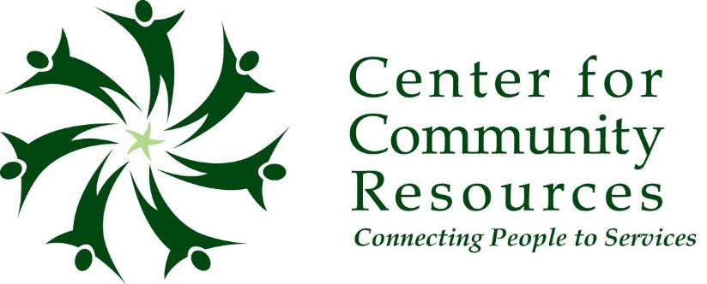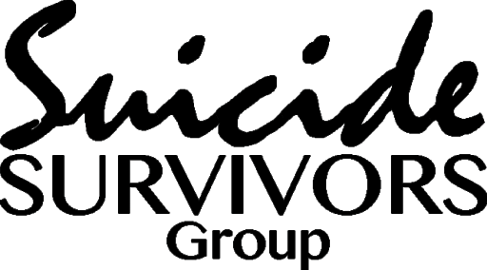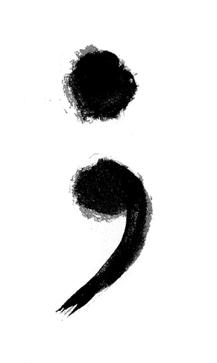

Center for Community Resources is offering a 6-week program for suicide survivors ages 25+. This group will offer a judgement-free and safe ZOOM session for survivors to work with PhD level clinicians in working through SAMHSA’s workbook *A Journey Toward Health and Hope.*

If you or anyone you know are interested in learning more information please contact a CCR grant liaison:

**Sarah Miller: 814-907-1558 samiller@ccrinfo.org**

**Madison Rinker: 814-470-0548 mrinker@ccrinfo.org**

Do you or someone you know continue to struggle with a past suicide attempt? Have you hidden your story because you didn’t know where to find a recovery-based group of peers who understand that your story isn’t done being written?